**Fabric and Window treatments**

**IDEC1045**

**WEEK 10, Fabric care codes**

1. Replace the highlighted areas above.
2. Fill in the cells on the right in the table below.

## Week at a Glance

|  |  |
| --- | --- |
| **Week at a Glance** | |
| This week’s course learning outcomes (number and text) | **CLO03:** Explain fabric and drapery terminology, dye lot differences, pattern repeat, railroading and common care codes for cleaning and maintaining materials. |
| This week’s unit learning outcomes (number and text) | **Unit 8:**  8.1 Identify uses of fire coding  8.2 Describe cleaning codes for various fabrics  8.3 Compare fabric protections |
|  | |
| This week’s problem | This week is making the student more aware of cleaning and fire codes on fabrics. This is important to understand because the care and maintenance of fabrics will save costly errors by assuming that it can be cleaned or washed without a thought. Some aftermarket treatments will negate the fabric warranty, while some cleaning methods will damage the material. |
| How does this week’s problem fit into the course so far? | This is a less intense lesson after dealing with measuring and calculating for several weeks. This week is a wrap up of how to take care of the fabrics once made and to be able to inform their clients of cleaning recommendations for long life to the treatment. We will also look at some bare windows and ask for student input to treatment ideas in a discussion forum or activity. |
| List of topics and subtopics that will be covered to address this week’s problem | **Care and cleaning codes:**   * Fire coding * Cleaning code symbols * Fabric protections * Spot cleaning ideas   **Window treatment ideas and recommendations**   * Window treatment ideas and tips   What were they thinking?   * Share your ideas in a discussion board about these rooms and how you would treat the windows |
| If this is a hybrid course, what topics and activities will be covered in-class to support the online content? |  |
| How does problem fit into the remaining weeks of the course? | The student should be very busy working on the final project at this point and this shorter and less intense lesson is meant to take some of the pressure off and give them time to complete the project and study for the exam. |
|  | |
| Graded Assessment? | Yes. Fill out the Evaluation section below.  No. |

## Introduction

|  |  |
| --- | --- |
| **Introduction to Week** | |
| Introduction | Description of content for this week:   * Explain what the user will learn * Describe the problem the user will be able to solve by the end of week * Answer the question “What’s in it for me (the learner)?”   You have had some intense weeks learning about window treatments, how to measure and calculate fabric amounts. You should be very busy at this point working on your final project that is due week 12 and so this week we will ease up a bit and talk about cleaning and fire codes. I always find it important to be aware of some cleaning codes that I can share with my clients on maintaining the material after they have it in their home. This week is meant to inform you of some of these and some after-market treatment and cleaning tips you can pass along with your window treatments. We will also look at some bare windows and get your ideas as to how you would treat them, what kind of window treatment ideas you have that can be shared with others in a discussion forum. |
| Learning Outcomes | Write out the week’s unit learning outcomes here (number and text).  **Unit 8:**  8.1 Identify uses of fire coding  8.2 Describe cleaning codes for various fabrics  8.3 Compare fabric protections |
| Other relevant announcements/ reminders | Insert notes on assignments and/or anything out of the ordinary.  Note: You can also add an image here for a front cover page look and feel.  Click here to enter text. |

****************** Beginning of instructional content ************************

Care and cleaning codes:

All fabrics need some kind of cleaning when necessary. Usually drapery treatments do not need cleaning other than dusting or vacuuming. However when soiling does happen it is important to understand what kind of cleaning is necessary to do the job and not damage the material, hard or soft. We will look at some of the cleaning code symbols and what they mean as well as describe some of the fire coding tests done that apply to natural and synthetic fibers. When purchasing a window treatment make sure to ask about the cleaning and care needed to properly care for the fabric or treatment to provide safe and long lasting wear.

**NOTE:** This information will not be on the exam, however you should make note when selecting fabrics and materials for your final project to pay attention to the compatibility of materials to the needs of your client.

## Fire coding

Fire coding is labeled on the back of fabric when sold in books. When creating treatments for commercial locations such as schools, churches, auditoriums, and theatres. The law states that the materials must be certified as flame retardant. This is overseen by NFPA, the National Fire Prevention Association who sets the standards depending on how the fabric is to be used. The UFAC, the Upholstered Furniture Action Council, also does testing on materials for that industry.

You can find this information on the back of all book style fabrics. There are different codes that meet different standards. Fabric companies also carry commercial lines that are fire retardant certified that are most often the go to area when decorating a commercial space. We are concentrating on residential decorating in this course, however I usually try and look for a good fire code label especially for children’s rooms or areas such as kitchens where stoves and ovens are located as well as bedding. Since fabrics come from all over the world, these two code companies are the most commonly recognized by the fabric industry standards.

By Linda Guthro

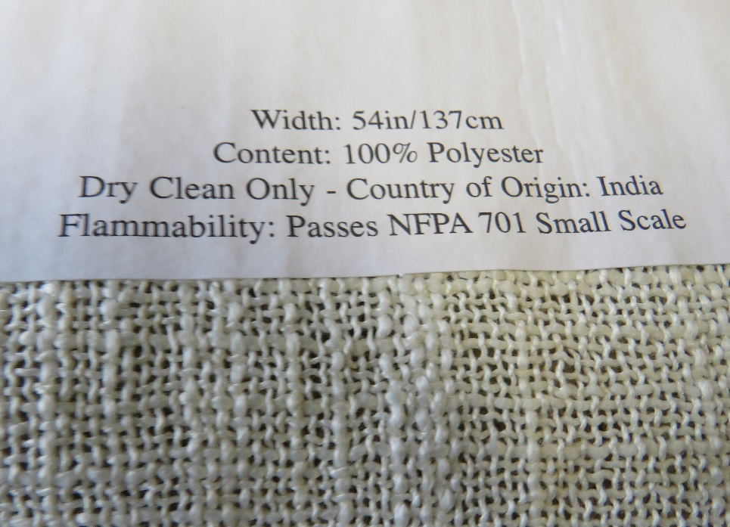

**There are different codes relating to categories of use such as:**

NFPA701 = flame resistance for fabrics and fibers

NFPA260 & UFAC Class 1 = Upholstery fabric

**To explain the meaning of these a bit further:**

**UFAC class 1** is a basic test method to determine flammability performance of upholstery fabric in contact with polyurethane foam (usually the seat cushions). Specifically to cigarette ignition resistance so that if the fabric passes is a class 1.

**UFAC class 2** means that the material did not meet the criteria and failed. To pass it must be used in conjunction with a flame-retardant lining material between the textile cover and the upholstery foam.

**NFPA260** is the test method determining resistance to cigarette ignition for materials used in upholstered furniture. They use a small scale composite test with a smoldering cigarette to drapery, curtains and other hanging textiles to measure the flammability of a fabric when exposed to a specific source of ignition. They rate the materials resistance after exposed to a flame for 12 seconds to measure the flame, char length and flaming residue and record the results. If an after flame is less than 2 seconds, a char length is less than 6 ½” and does not continue to flame after reaching he floor of the test chamber it is certified as flame retardant and is certified to receive the pass code.

**NFPA701** is a common code for fabrics for drapery. The NFPA701 small scale code means that if a drapery fabric once exposed to a flame has no after flame under 2 seconds, no more than 6 ½” of char length and extinguishes once it reaches the test room floor.

If you see the fabric you are selecting shows a fire retardant code you will know they have passed the flame retardant standards.

This is the Canadian website with lots of information on Canadian test standards…

<http://www.hc-sc.gc.ca/cps-spc/pubs/indust/flammability-inflammabilite/index-eng.php#a3>

## Cleaning code symbols

It cannot be assumed that all fabrics can be cleaned the same way. Many people think that if for example fabric is cotton it is washable but nothing can be further from the truth. Depending on how a fabric is made and the treatments it receives afterward, they can all react in different ways. A fabric sample may be washable under certain conditions or need dry cleaning or other care necessities. We are all familiar with some of the common care icons as shown in this photo

Istock id: 480716257

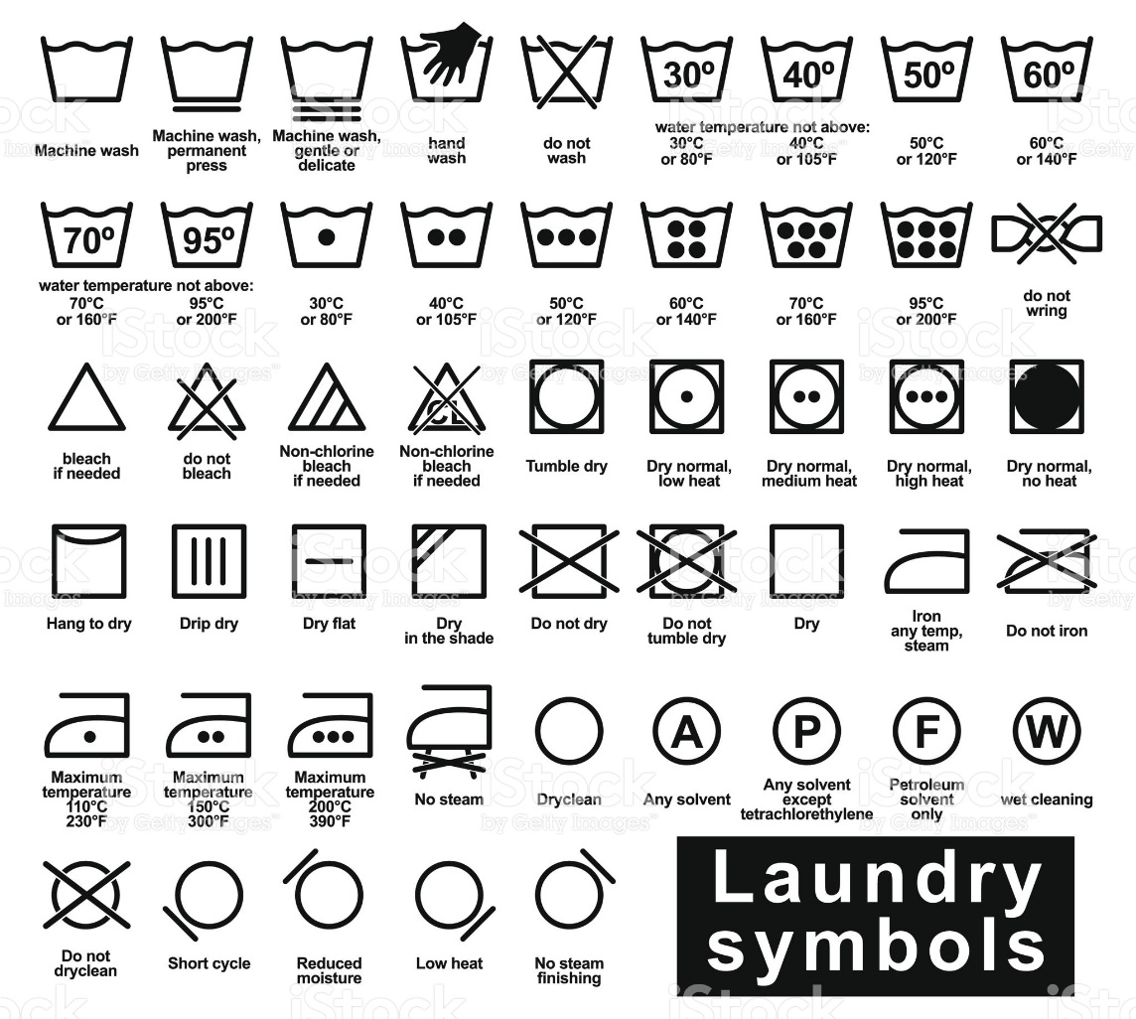

For all cleaning, many household cleaning products can be harmful to the colour and life of fabrics and professional cleaning is recommended. To prevent over soiling, frequent vacuuming or light brushing is recommended. Make sure to always include the cleaning method recommended to your client. It is a good idea to provide your client with the fabric content and recommended cleaning when they purchase a treatment from you.

**These are some symbols you may come across and how they are to be cleaned:**

**W:**

* Use water-based cleaner
* Spot clean with the foam only of a water-based cleaning agent like mild detergent or commercial upholstery shampoo
* Use sparingly to avoid over wetting

**WA:**

* Washable, consult fabric or fabric book for individual instructions about temperature and other conditions.

**S:**

* Use solvent cleaner
* Spot clean with mild water-free dry cleaning solvent available at local stores
* Use sparingly in well ventilated room with no sparks or flame in the room
* Caution: Use of water-based solvent cleaners may cause spotting and/or excessive shrinking
* Solvent cleaning agents will not remove water stains.

**S-W:**

* Can use water-based or solvent cleaner
* Spot clean with a dry cleaning solvent, mild detergent foam or upholstery shampoo depending on the stain.

**P:**

* Resistant against perchlorethene, cleaning benzene (spirit), white spirit R11 and R113
* “_” symbol under the P means limited addition of water, less mechanical treatment or lower drying temperature needed

**F:**

* Resistant against cleaning benzene (spirit), white spirit and R113

**X:**

* Clean by vacuuming only or light brushing to prevent accumulation of dust and grime
* Water-based foam or solvent based cleaning agents of any kind may cause excessive shrinking fading or spotting

It is strongly recommended that any fabric be tested by the dry cleaner before proceeding to ensure that the dry cleaners methods do not damage the fabric

## Fabric protections

There are some fabric protections you can have added to your fabric after purchase. Make sure they are not contrary to the recommended care of the fabric. Think of spraying a fabric protection to dining chair seat covers to avoid staining. This is a great idea if there are small children living in the home to prolong cleaning.

## Window treatment ideas and recommendations

There are multitudes of window treatment styles, fabrics and looks for our homes. No treatment is sometimes an option of course, however since we are talking about window treatments, no treatment at all is not an option this semester. Some great looks are shown here and why they are suitable for the rooms they are in. Think of your own ideas and let your imagination come up with new ideas that suit the needs of any room in your home.

### Window treatment ideas and tips

1. When hanging multiple treatments in a room, keeping them all at the same height gives a uniform look to the room

Istock id: 174767456



2. Not all treatments have to match in a room, however they do need to co-ordinate. Notice in this room there are 3 kinds of fabric used on the windows.

Istock id:



3. This lavish room has very high ceilings and windows. Whenever you have an area of trim like showing on these windows you can hang your drapes lower at that trim level. Hanging your drapery there instead of full height will save money in fabric and lower the feel of the ceiling to the living level of the room. Place the rod so that it is in the middle of the trim which would be about 8” or more tall in this case is an option for grand rooms like this.

Istock id: 157316174



4. This room looks very elegant with the swag and jabot treatments in this traditional room.

Istock id: 157334717



5. A small amount of colour on these drapery add a lot to the room and tie in the blues used as accent in this room. Notice that the window beside the fireplace is a shutter and co-ordinates well with the décor.

Istock id:

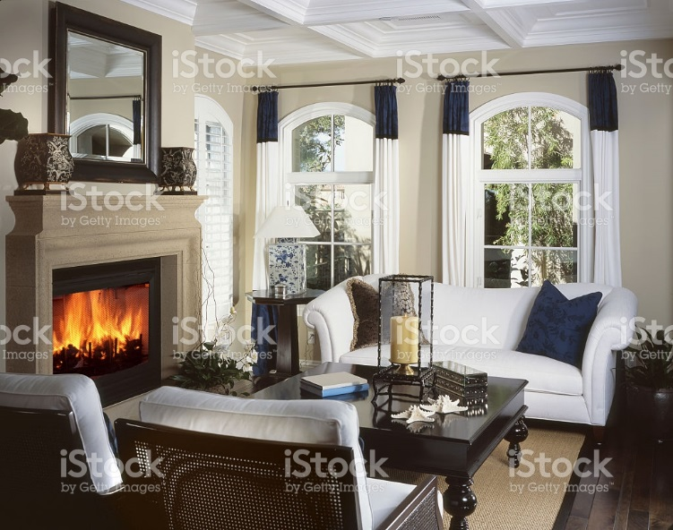

6. These blinds in this bathroom are an excellent choice for light control and privacy. When in doubt for any kind of treatment…keep it simple.

Istock id: 183256906

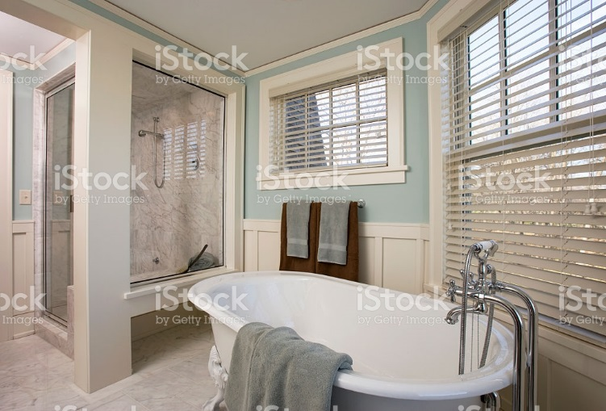

7. These are sliding panel shutters that create a tailored and functional addition to the room. Sliding panels can be fabric or shutters and are becoming extremely popular options.

Istock id: 186826957



8. This beautiful padded cornice makes a great statement in this room.

Istock id: 480485243



### What would you do with these windows?

We need a discussion board for these photos

Share your ideas about these rooms and describe how you would treat the windows

Istock id: 170094599

1. 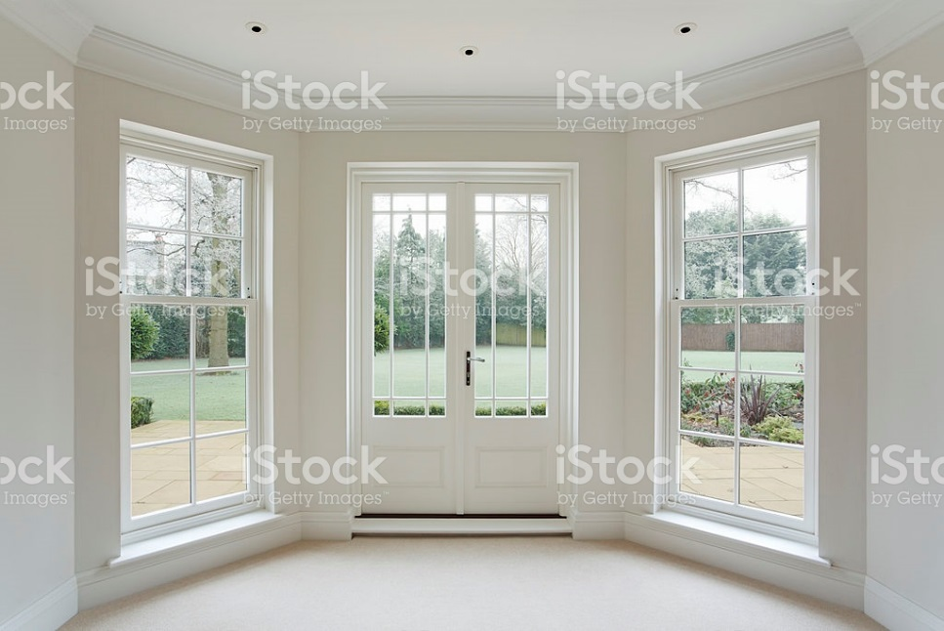

Istock id: 183612641

2. 

Istock id: 171591165

3. 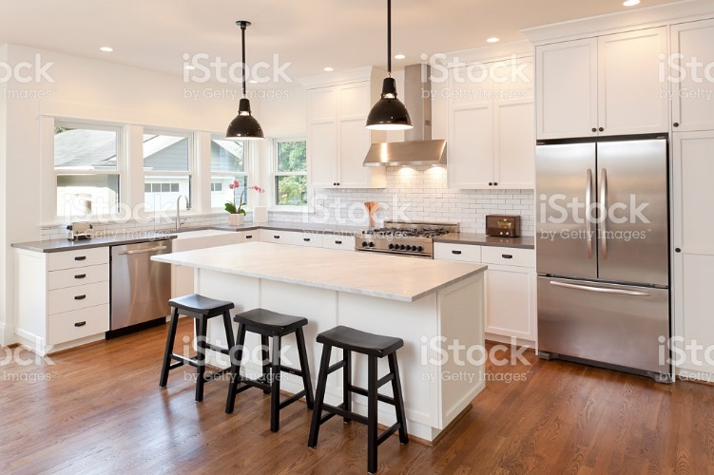

## Conclusion:

As you have seen during this semester, choosing the proper window treatment is not a five minute experience. Selecting the right window covering takes planning, exact measurements and a knowledge of the pros and cons of different kinds of treatments, fabrics and hardware. When you visit a company that specializes in window coverings both hard and soft, you will discover that there are knowledgeable staff who know their products and manufacturers well and are there to walk you through the entire process before, during and after. They have all price ranges from a $50.00 blind up to the most expensive and will stand behind all their products. I encourage you to deal with a real professional to make your investment in window coverings a positive experience and one that will serve you personally and professionally throughout the life of the treatment.

********************* End of instructional content *************************

## Evaluation

Fill out the cells on the right in the table below as appropriate. If the evaluation is one of the following, copy and paste the appropriate table(s) after the evaluation table:

* Discussion
* Quiz or test: Insert one table for each question
* Dropbox

|  |  |
| --- | --- |
| **Evaluation** | |
| What type of assessment will be included? | Discussion  Written Assignment  Test or Quiz  Individual Project  Group Project  Other. Describe: Click here to enter text. |
| When is the assessment due? | For example, last day of week at 11:55 p.m. Click here to enter text. |
| How long is the assessment? | For example, a test may be 120 minutes or a written assignment may be 500 words. Click here to enter text. |
| What is the weighted value of the assessment? | For example, 20% of the final grade. Click here to enter text. |
| List the course learning outcomes for this assessment (number and text). This information must match the Evaluation Matrix. | Click here to enter text. |
| How does the assessment connect with the lesson or the overall goals of the course? | Click here to enter text. |
| Instructions | Use this area to explain:   * what the assignment is * important criteria   Click here to enter text. |
| Rubric or Marking Scheme | Use this area to explain how the assignment will be assessed or indicate the file name for the rubric.  Click here to enter text. |